Quiz 4 SVM and Kernel Method
- Linearly Separable Example (10 points)
Build the best SVM linear classifier for the following (tiny) data set shown in Figure below. Show your solutions for w and b. It is required that you solve the margin ρ=2/|w|. Add your SVM decision boundary on the figure below. Note that there are three instances, each with two features, and this is a binary classification problem.
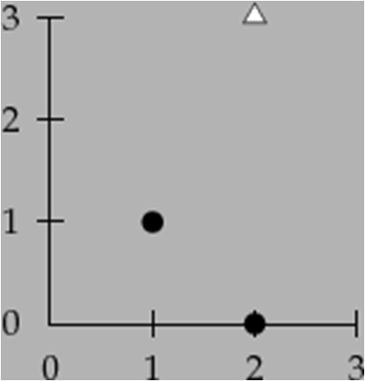

Kernel Method (Extra Credits, for advanced students only)
Consider an example of 3 1-dimensional data points: x1= -1, x2 = 0, x3 = 1. And the labels, y1 = y3 = 1 while y2 = -
- Note that it is a (tiny) binary classification problem with non-linearly separable data. We are going to use standard Kernel method to find the SVM classifier. The purpose of this problem is to understand how the kernel method is used to find SVM classifier for non-linearly separable data. The example is artificially small and manageable; therefore, all the calculations should be done manually (without computer programming). We use polynomial kernel of degree 2:
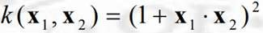 and the mapping to the high dimensional feature space is:
φ(x) = [1, √2x, x²]. The images in the feature space are (1, -√2, 1), (1, 0, 0), and (1, √2, 1). (Note that this is a 2- dimensional space since the first items are all 1s therefore nominal).
To understand the consistency between the kernel function k and the mapping φ(x), note that: the dot product between φ(x1) and φ(x2),
φ(x1)·φ(x2) = 1*1 + (√2 x1)*(√2 x2) + (x ²)*(x ²) = (1 + x1 x2 )² = k(x1 , x2 )
1 2

The kernel function takes inputs and returns the dot product of the high-dimensional images of the inputs.

We are going to follow these steps (consider most of the materials here a tutorial on kernel method, additional examples can be found in the ppt file for Week 13 on D2L site):

  - The dual form of the optimization writes:

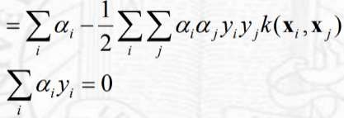
L

subject to

Note that the dot product term in the linearly separable formulation is replaced with our kernel function that, given inputs, produces the dot product of images in the feature space.

In the context of our problem, the objective function is
max L = α1 + α2 + α3- 0.5(4α ² + α ² + 4α32) + α1α2 + α2α3
1 2
s.t. α1 - α2 + α3 = 0
You may want to reproduce the above equation for understanding (or double check for error, but I think it is safe to use it for the rest of the problem).
Now, you should solve this dual form of constraint optimization with respect to α1 , α2 , and α3 It is obvious that all three points are support vectors and thus have positive α’s.

  - Use the optimal values to get the values of our model parameters Ws and b using the formula:
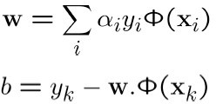

  - What is the SVM classifier?
An easier way (recommended) to complete 2 and 3 above together is to follow the techniques in Slide # 81, using this formula:
f(x) = Σα y k(xi, x) + b
i i

Note that xi represents the training data points and x remains as x, representing a new data point to be classified.

  - Please visualize the non-linear decision boundary in a 2-dimensional space.

